Exercise 1 Spring Data JPA Quick Example

Step 1: Create Spring Boot Project
Go to start.spring.io
Select:
- Project: Maven
- Language: Java
- Spring Boot: 3.2.x
- Java: 21
Dependencies:
- Spring Web
- Spring Data JPA
- H2 Database

Step 2: Setup Application properties and add JPA
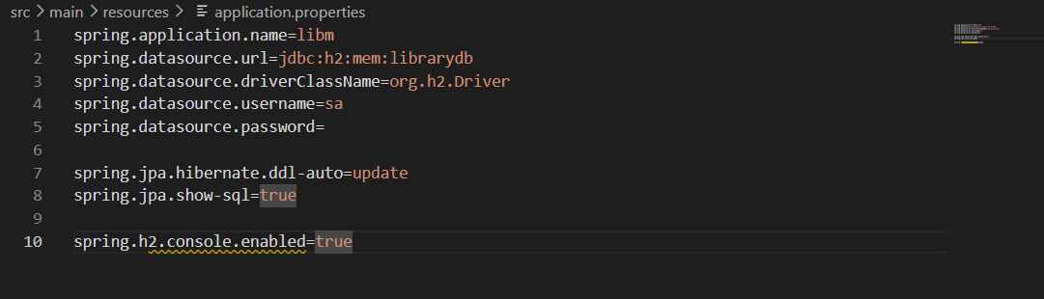

Create the entity and repository for the data and also create the controllers for every endpoint and run the application

Entity
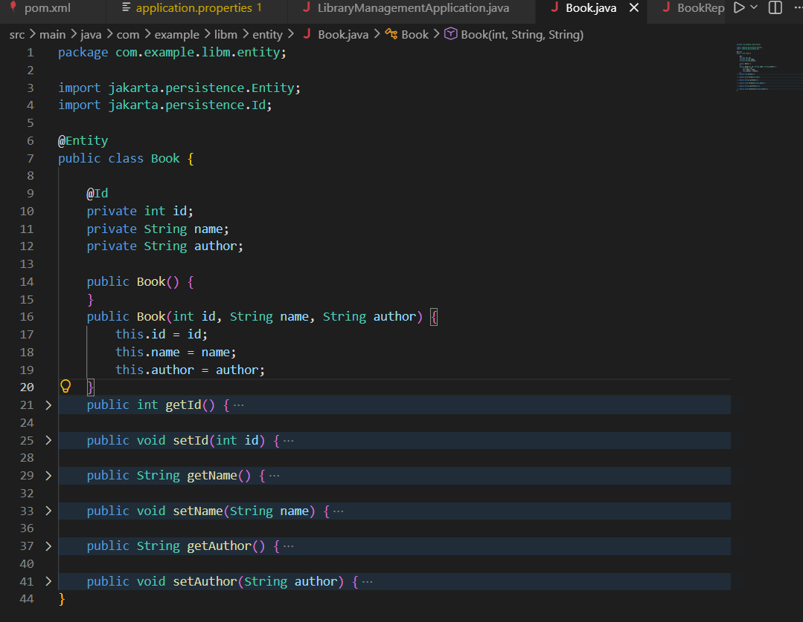

Repository
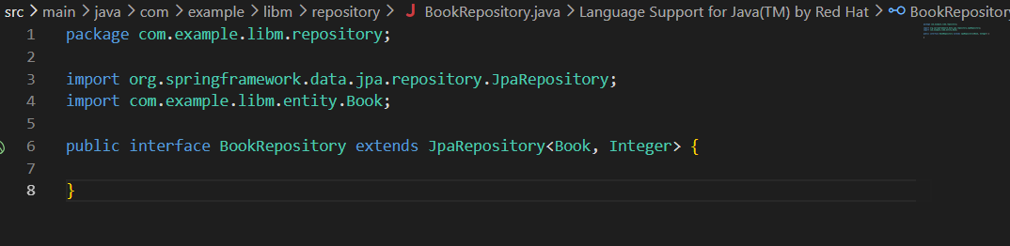

Controllers
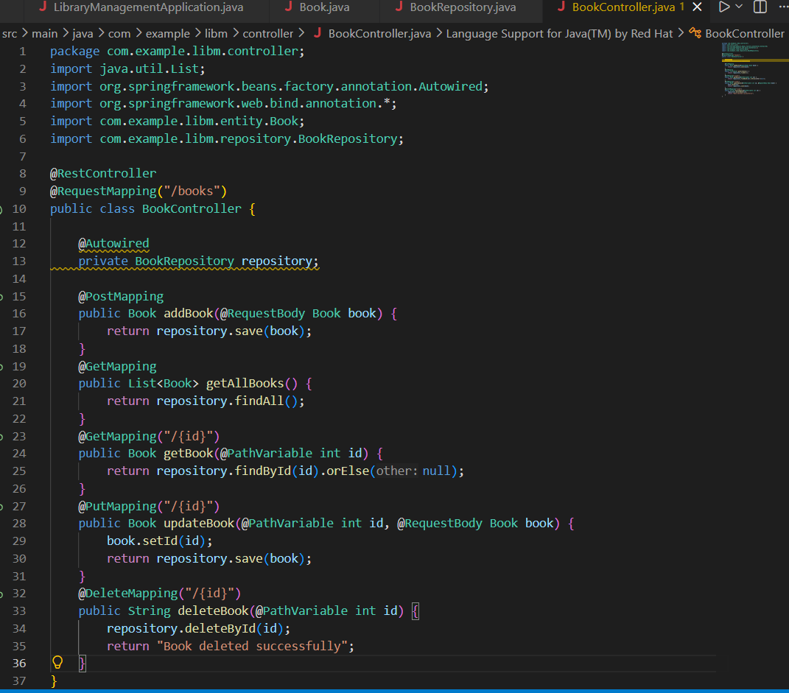
Main class
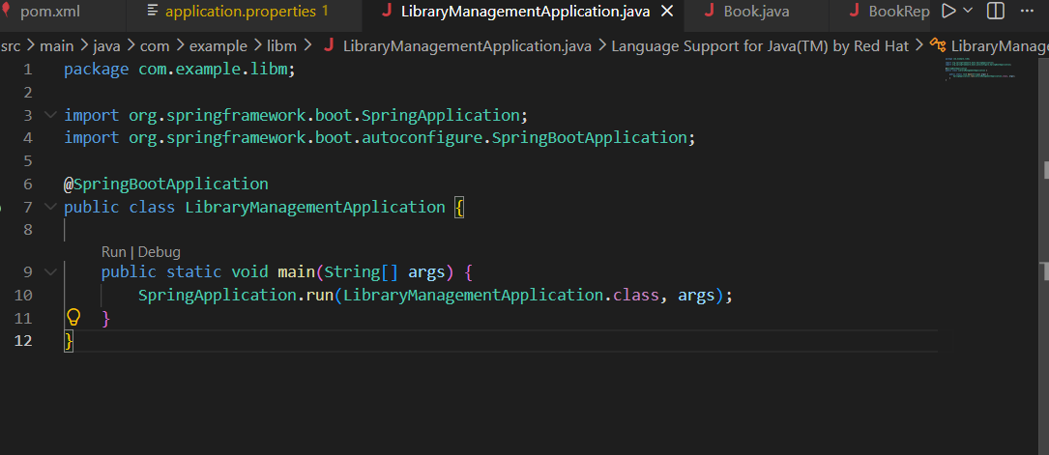
Output

Post data
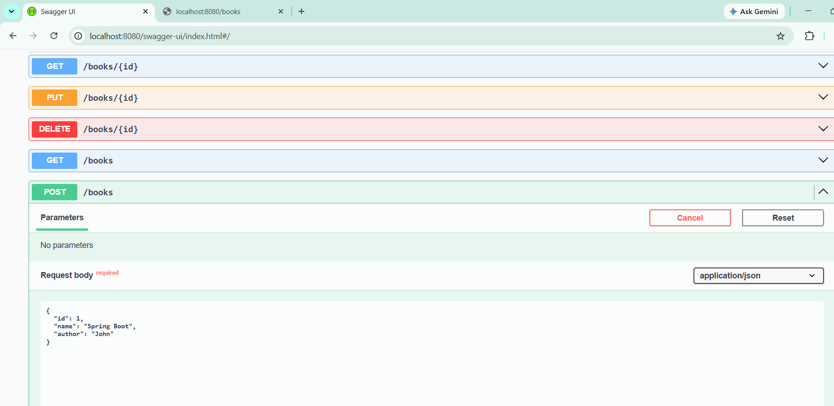

Get data
